JavaScript Algorithms and Data Structures Masterclass

# Section 26: Graph Traversal

## What is Traversal?

* Visiting/Updating/Checking each vertex in a graph
  + **Examples**:
    - 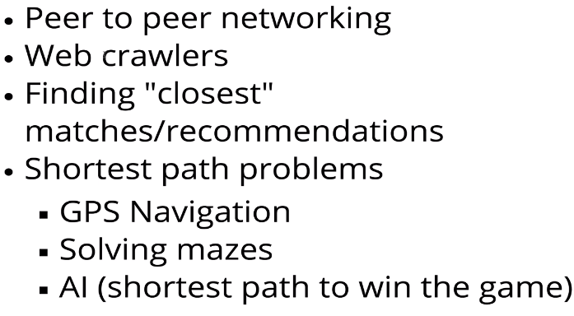

## Types of Traversals (Recursive and Iterative)

### Depth First Search (aka DFS Traversal)

* Explore as far as possible down one branch before “backtracking”
  + **Diagram**:
    - 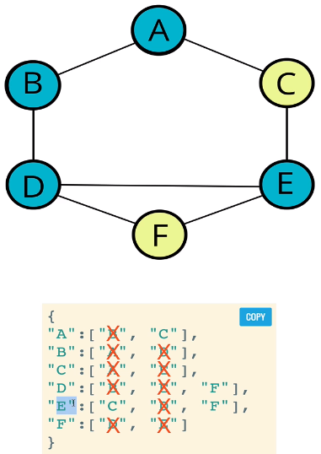 - cross-off as we go through the vertices
* **Recursive**
  + **Psuedo-code**:
    - 
     